University of Basrah Al-Zahraa Medical College


Ministry of higher Education
and Scientific Research

Academic year 2025-2026 5th year
REPRODUCTIVE BLOCK
Lecture
Duration : 1 hour
NORMAL LABOUR Presented by
Dr.Heba Salman

Block staff:
Dr.Marwa Sadiq (Block leader)


Dr. Raya muslim
Dr.Safa Kiffah
GYNAECOLOGY 20th EDITION by Ten Teachers
University of Basrah Al-Zahraa Medical College

Learning Objectives (LO)
1- Diagnosis , stages and duration of Labor . 2- Management of labor .
3-Fetal assessment options in labor
4-Management during first stage .
5-Management of second stage of labor. 6-Management of third stage of labor .

Ministry of higher Education
and Scientific Research
LO 1
Diagnosis of labour

The onset of labor can be defined as the presence of strong regular painful contractions resulting in progressive cervical change.
Stages of labour

Labor can be divided into three stages :

First stage

This describes the time from the diagnosis of labour to full dilatation of the cervix (10 cm). The first stage of labour can be divided into two phases. The ‘latent phase’ is the time between the onset of regular painful contractions and 3–4 cm cervical dilatation. During this time, the cervix becomes ‘fully effaced’. Effacement is a process by which the cervix shortens in length as it becomes incorporated into the lower segment of the uterus.

• The duration of the latent phase is variable, it usually lasts between 3 and 8
hours, being shorter in multiparous women.
• The second phase of the first stage of labour is called the ‘active phase’ and describes the time between the end of the latent phase (3–4 cm dilatation) and full cervical dilatation (10 cm). It is also variable in length, usually lasting between 2 and 6 hours, shorter in multiparous women. Cervical dilatation during the active phase occurs typically at 1 cm/hour or more in a normal labour, but is only considered abnormal if it occurs at less than 1 cm in 2 hours.
Second stage

This describes the time from full dilatation of the cervix to delivery of the fetus or fetuses. The second stage of labour may also be subdivided into two phases. The ‘passive phase’ describes the time between full dilatation and the onset of
involuntary expulsive contractions. There is no maternal urge to push and the fetal head is still relatively high in the pelvis. The second phase is called the
‘active second stage’. There is a maternal urge to push because the fetal head is low (often visible), causing a reflex need to ‘bear down’.

A normal active second stage should last no longer than 2 hours in a nulliparous woman and 1 hour in women who delivered vaginally before.
Third stage

This is the time from delivery of the fetus or fetuses until complete delivery of the placenta(e) and membranes. The placenta is usually delivered within a few minutes of the birth of the baby. A third stage lasting more than 30 minutes is
defined as abnormal, unless the woman has opted for ‘physiological management’ in which case it is reasonable to extend this definition to 60 minutes.
The duration of labor

It is difficult to define prolonged labour, labour lasting longer than 12 hours in nulliparous women and 8 hours in multiparous women should be regarded as prolonged. Precipitous labor is defined as expulsion of the fetus within less than 3 hours of the onset of regular contractions.
LO 2
Management of Labor Admission history

1. Previous births and size of previous babies.
2. Previous caesarean section.
3. Onset, frequency, duration and perception of strength of the contractions.
4. Whether membranes have ruptured and, if so, colour and amount of amniotic fluid lost.
5. Presence of abnormal vaginal discharge or bleeding.
6. Recent activity of the fetus (fetal movement).
7. Medical or obstetric issues of note (e.g. diabetes, hypertension, fetal growth restriction
[FGR]).
8. Any special requirements (e.g. an interpreter or particular emotional/psychological needs).
9. Maternal expectations of labour and delivery?
10.Birth preferences or a birth plan?
Abdominal examination

After the initial inspection for scars indicating previous surgery:

1. determine the lie of the fetus (longitudinal, transverse or oblique)
2. the nature of the presenting part (cephalic or breech). If it is a cephalic
presentation, the degree of engagement must be determined in terms of fifths palpable abdominally.
3. an assessment of the contractions; this takes time (at least 10 minutes) and is
done by palpating the uterus directly .
Vaginal examination

• The purpose and technique of vaginal examination is explained to the woman and her consent must be obtained. Most women find vaginal examinations
uncomfortable and every effort should be made to maintain the woman’s
dignity and privacy.
• A vaginal examination also allows assessment of the fetal head position,
station, attitude and the presence of caput or moulding.

• The condition of the membranes should also be noted. If they have ruptured,
the colour and amount of amniotic fluid draining should be noted.
• The frequency of contractions should be recorded every 30 minutes and a
vaginal examination performed every 4 hours .
LO 3
Fetal assessment options in labor

1. Inspection of amniotic fluid – fresh meconium staining, absence of fluid, and
heavy blood-stained fluid or bleeding are markers of potential fetal
compromise.
2. Intermittent auscultation of the fetal heart using a Pinard stethoscope or a
handheld Doppler ultrasound.
3. Continuous external electronic fetal monitoring (EFM) using CTG.
4. Continuous internal electronic fetal monitoring using a fetal scalp electrode
(FSE) and CTG.
5. Fetal scalp blood sampling (FBS).

The FHR should be auscultated with a Pinard stethoscope, or by using a
handheld Doppler device, early on in the initial assessment. It should be listened to for at least 1 minute immediately after a contraction. This should be repeated every 15 minutes during the first stage of labour and at least every 5 minutes in the second stage.
Indications for continuous EFM

1. Significant meconium staining of the amniotic fluid.
2. Abnormal FHR detected by intermittent auscultation.
3. Maternal pyrexia (temperature ≥38.0°C or ≥37.5°C on two occasions). 4. Fresh vaginal bleeding.
5. Augmentation of contractions with an oxytocin infusion.
6. Maternal request.

features of a normal FHR pattern include a baseline heart rate of between 110 and 160 bpm (averaged over a 20 minute interval or more), variability of between 5 and 25 bpm (variation in the FHR above and below the baseline), accelerations (a transient increase in FHR of at least 15 bpm lasting at least 15 seconds) and the absence of decelerations (transient decrease in the FHR of 15 bpm or more).



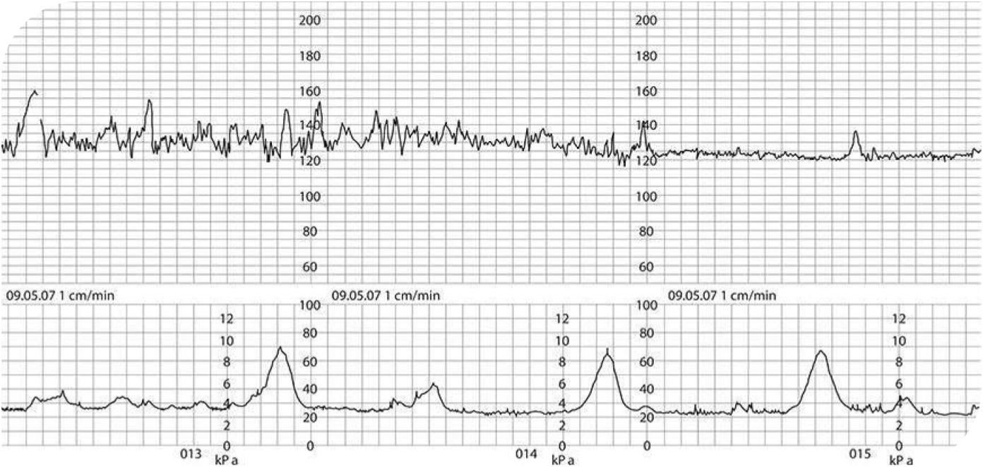

A normal cardiotocograph (CTG), showing a baseline fetal heart rate of approximately 120 bpm, frequent accelerations, baseline variability of 10– 15 bpm and no decelerations. The uterus is contracting
approximately once every 5 minutes.
The partogram

This record allows an instant visual assessment of the progress of labour based on the rate of cervical dilatation compared with an expected norm, according to the parity of the woman, so that slow progress can be recognized early and appropriate actions taken to correct it where possible.
LO 4
Management during first stage :
• Women who are in the latent phase of labour should be encouraged to mobilize and should be managed away from the labour suite where possible.
• The lower limit of normal progress is 1 cm dilatation every 2 hours once the
active phase has been reached.

• ‘Active management of labour’ was a collection of interventions that was
routinely recommended to nulliparous women to maximize the chances of a normal birth. It included one-to-one midwifery care, 2-hourly vaginal
examinations, early artificial rupture of membranes and use of oxytocin augmentation if progress fell more than 2 hours behind the schedule of 1 cm
dilatation per hour.
LO 5
Management of second stage of labor
❖Descent and delivery of the head

• When the head no longer recedes between contractions it is described as crowning. This indicates that it has passed through the pelvic floor, and delivery is imminent.
• The ‘hands-on’ approach has been very popular. As crowning occurs, the hands of the accoucheur are used to flex the fetal head and guard the perineum. The belief is that controlling the speed of delivery of the fetal head will limit maternal soft-tissue damage .

• An episiotomy is a surgical cut, performed with scissors, which extends from
the vaginal fourchette in a mediolateral direction, usually to the right .
• Effective analgesia is required, and this will usually be with infiltration of
local anesthetic if the woman does not have an epidural.
❖Delivery of the shoulders and rest of the body

With the next contraction, there is restitution and external rotation of the head and the shoulders can be delivered. To aid delivery of the shoulders, there should be gentle traction on the head downwards and forwards until the anterior shoulder appears beneath the pubis. The head is then lifted gradually until the posterior shoulder appears over the perineum and the baby is then swept upwards to deliver the body and legs.
Immediate care of the neonate

• The baby’s head should be kept dependent to allow mucus in the respiratory tract to drain, and oropharyngeal suction should only be applied if really necessary. After clamping and cutting the cord, the baby should have an Apgar score calculated at 1 minute of age which is then repeated at 5 minutes.
• Immediate skin-to-skin contact between mother and baby will help bonding, and promote the further release of oxytocin, which will encourage uterine contractions.

• The baby should be dried and covered with a warm blanket or towel,
maintaining this contact.
• Initiation of breastfeeding should be encouraged within the first hour of life, and routine newborn measurements of head circumference, birthweight and temperature are usually performed soon after this hour has elapsed.
• Before being taken from the delivery room, the first dose of vitamin K should be given (if parental consent has been given) and the infant should have a general examination for abnormalities and a wrist label attached for identification.
LO 6
Management of third stage of labor
Signs of placental separation :
1. Apparent lengthening of the cord.
2. A small gush of blood from the placental bed.
3. Rising of the uterine fundus to above the umbilicus .
4. Uterine contraction resulting in firm globular feel on palpation.
❖Active management of the third stage :
stage
1. Intramuscular injection of 10 IU oxytocin, given as the anterior shoulder of
the baby is delivered, or immediately after delivery of the baby.
2. Early clamping and cutting of the umbilical cord.
3. Controlled cord traction .
❖Physiological management

After completion of the third stage, the placenta should be inspected for missing cotyledons or a succenturiate lobe. If these are suspected, examination under anaesthesia and manual removal of placental tissue (MROP) should be arranged, because in this situation the risk of PPH is high.

